Circuit 2: Multiplier

KiCad Screenshot:
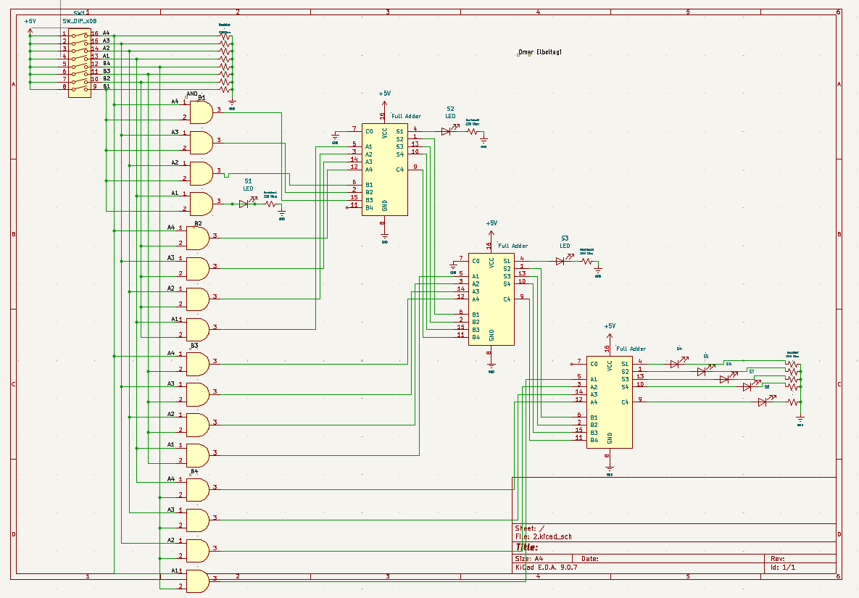

TinkerCad Screenshot:

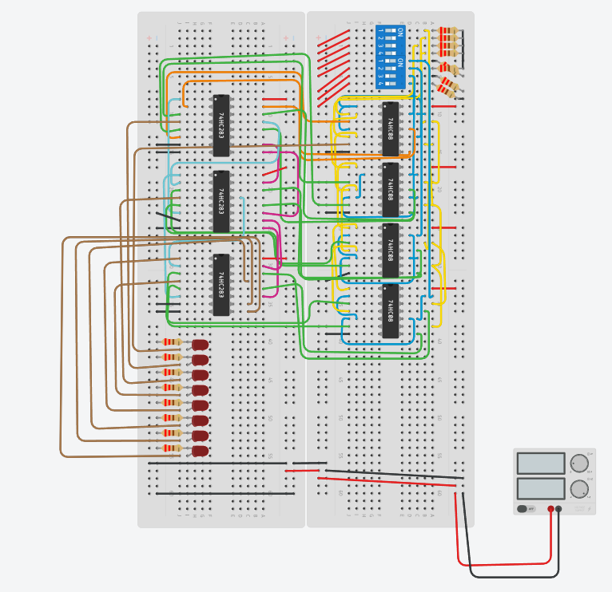

The Circuit Link

Multiplication Truth Table:

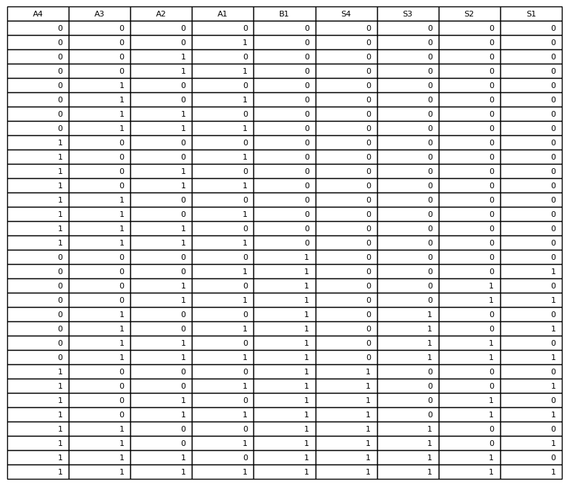

Description:

The circuit shown is a 4-bit unsigned multiplier.
This circuit is based on the concept of binary multiplication and the fact that addition is commutative. In binary multiplication, we begin with the least significant bit (LSB) of the bottom row and multiply it by each bit of the top row, moving from LSB to MSB, similar to how multiplication is done in decimal numbers.
We continue this process for each bit of the bottom row, shifting left as we move toward the most significant bit (MSB). Each step generates a partial product, and all partial products are then added together to produce the final result. The corresponding truth table for this operation is shown above.
From the Multiplication Truth Table, we can observe that when B1 = 0, all outputs are 0. When B1 = 1, the output directly reflects the values of A4–A1. This same pattern applies for the remaining bits (B2, B3, B4), with each partial product shifted accordingly.
In the final stage all partial products are summed using adders. Since addition is commutative, the order of addition does not affect the result. For the least significant bit (S1), the output is simply A1 × B1. As more bits are added, zeros are introduced where needed due to shifting. Each adder passes its carry-out to the next stage, and the final carry-out becomes the most significant bit (MSB) of the result.

